**PROJECT TITLE: Chatbot Deployment With IBM Cloud Watson Assistant**

**Submitted By**

**Ananthi.S**

**920121104003**

**BE. CSE**

**Bharath Niketan Engineering**

**College**

**Introduction**

IBM Watson® Natural Language Understanding uses deep learning to extract meaning and metadata from unstructured text data. Get underneath your data using text analytics to extract categories, classification, entities, keywords, sentiment, emotion, relations and syntax.

Natural Language Understanding is a best-of-breed text analytics service that can be integrated into an existing data pipeline that supports 13 languages depending on the feature. NLU is hosted in Dallas, Washington, D.C., Frankfurt, and Sydney.

* **Deploy Watson Natural Language Understanding behind your firewall or on any cloud.**
* **Train Watson to understand the language of your business and extract customized insights with Watson Knowledge Studio.**
* **Surface real-time actionable insights to provide your employees with the tools they need to pull meta-data and patterns from massive troves of data.**

**Natural Language Processing(NLP)**

**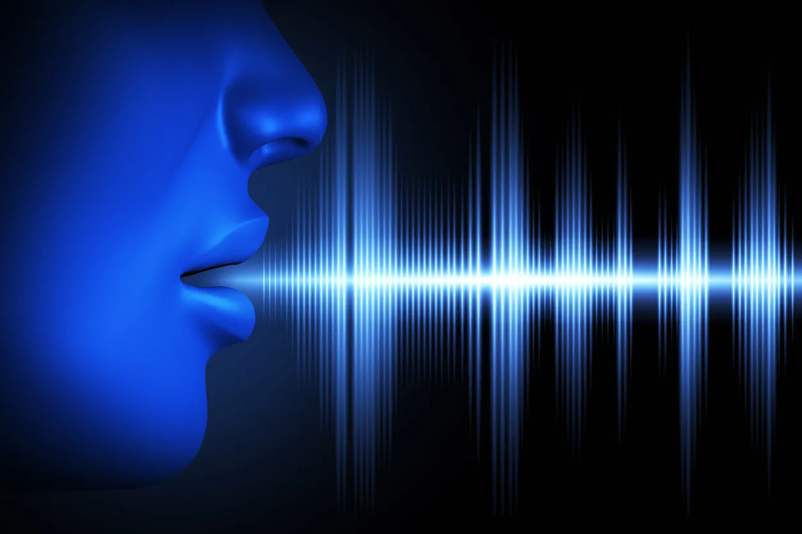**

Natural Language Processing is based on [deep learning](https://www.marutitech.com/top-8-deep-learning-frameworks/" \t "_blank) that enables computers to acquire meaning from inputs given by users. In the context of bots, it assesses the intent of the input from the users and then creates responses based on a contextual analysis similar to a human being.

When it comes to Natural Language Processing, developers can train the bot on multiple interactions and conversations it will go through as well as providing multiple examples of content it will come in contact with as that tends to give it a much wider basis with which it can further assess and interpret queries more effectively.So, while training the bot sounds like a very tedious process, the results are very much worth it.

**Implementing NLU Features**

****Choose the Right NLU Framework:**** Select a robust NLU framework or toolset that aligns with your project requirements. Popular options include Dialogflow, LUIS, Wit.ai, or building a custom NLU model using libraries like spaCy or Rasa.

****Data Collection and Annotation:**** Gather a comprehensive dataset of user interactions and annotate it with intent labels. This labeled dataset will serve as the foundation for training and fine-tuning your NLU model.

****Intent Classification:**** Train your NLU model to accurately classify user intents. Implement techniques like deep learning, recurrent neural networks (RNNs), or transformers to achieve high accuracy.

****Entity Recognition:**** If your chatbot needs to extract specific information from user inputs (e.g., dates, names, locations), integrate entity recognition into your NLU pipeline.

****Multi-language Support:**** Consider the need for multi-language support if your chatbot is intended for a diverse audience. Ensure your NLU model can handle different languages effectively.

****Contextual Understanding:**** Enhance your NLU model's ability to understand context and maintain context across multiple turns in a conversation. This is crucial for handling follow-up questions and maintaining coherent interactions.

****Ambiguity Handling:**** Implement strategies to handle ambiguous user queries gracefully, such as asking clarifying questions when the intent is unclear.

****Error Handling:**** Develop a mechanism to gracefully handle cases when the NLU model cannot confidently recognize the user's intent or entities. This might involve providing informative error messages or offering suggestions to rephrase the query.

****Continuous Learning:**** Periodically update and retrain your NLU model using fresh data to adapt to changing user behavior and improve accuracy over time.

****Evaluation and Metrics:**** Use evaluation metrics like precision, recall, and F1-score to assess the performance of your NLU model. Conduct thorough testing to identify areas for improvement.

****Integration with Chatbot:**** Seamlessly integrate your NLU model into your chatbot application, ensuring that it can understand and respond to user inputs effectively.

****User Feedback Loop:**** Establish a feedback loop to gather user feedback and insights. This feedback can help you refine and enhance your NLU model continuously.

Implementing advanced NLU features will not only improve user intent recognition but also contribute to a more natural and engaging conversational experience with your chatbot.

**NLP Process Queries**

窗体顶端

****Intent**** — The central concept of constructing a conversational user interface and it is identified as the task a user wants to achieve or the problem statement a user is looking to solve.

****Utterance**** — The various different instances of sentences that a user may give as input to the chatbot as when they are referring to an intent.

****Entity**** — They include all characteristics and details pertinent to the user’s intent. This can range from location, date, time, etc.

****Context**** — This helps in saving and share different parameters over the entirety of the user’s session.

****Session**** — This essentially covers the start and end points of a user’s conversation.

There are many NLP engines available in the market right from [Google’s](https://dialogflow.com/" \t "_blank)Dialog flow (previously known as API.ai), [Wit.ai](https://wit.ai/" \t "_blank), [Watson Conversation Service](https://www.ibm.com/watson/services/conversation/" \t "_blank), [Lex](https://aws.amazon.com/lex/" \t "_blank) and more. Some services provide an all in one solution while some focus on resolving one single issue.

# **Natural Language Processing Need**

# ****1.Natural Conversations across Languages****

# ****2. Focus on Mission Critical Tasks****

# ****3. Reduced Cost****

# ****4. Higher Customer Satisfaction****

# ****5. Market Research and Analysis****

**Conclusion**

NLP based chatbots can help enhance your business processes and elevate customer experience to the next level while also increasing overall growth and profitability. It provides technological advantages to stay competitive in the market-saving time, effort and costs that further leads to increased customer satisfaction and increased engagements in your business.

While NLP alone is the key and can’t work miracles or make certain that a chatbot responds to every message effectively, it is crucial to a chatbot’s successful user experience.

窗体底端

**.**